ARCHITECT REVIEW
SCC-3386 | Field Technician Context
Great Plains Merge Sandbox | Read-only dry-run and readiness assessment
Environment | GreatPlainsMerge (Sandbox) | Org 00DEa00000GkAsHMAV
Review date | 26 August 2026
Retrieval | Succeeded | Job 09SEa00000ickQLMAY
Decision | Changes Requested - not ready for promotion
Boundary | No records, deployment, activation, or org metadata were changed

ARCHITECT DECISION
Do not promote yet. The Case-side fields are present, but the Work Order page wiring, technician field access, and Incident related-list configuration are incomplete.

Acceptance outcome
# | Scope | Result | Evidence
1 | Case fields and layout | Partial pass | Five fields exist; Contact Preference is restricted to 8 values; section order matches the test. Technician access fails.
2 | Related Outage | Partial fail | Lookup to Incident exists, but the only Incident layout lacks the Trouble Tickets related list.
3 | Create Work Order regression | Partial pass | SCC-3385 flow v1 is active/latest. Runtime mapping and duplicate behavior were not executed in this read-only review.
4 | Read-only detail on Work Order | Fail | Nine-field read-only quick action exists, but the only Work Order record page does not reference it or include a Related Record component.
5 | Field Service Mobile persona | Fail | Two active mobile users use GPC-Residential CRC Team; that profile and its assigned permission sets grant none of the required field access.

Solution and access path
The configured Case fields are usable by administrators, but the intended technician path breaks at both the Work Order page and field-security layers.
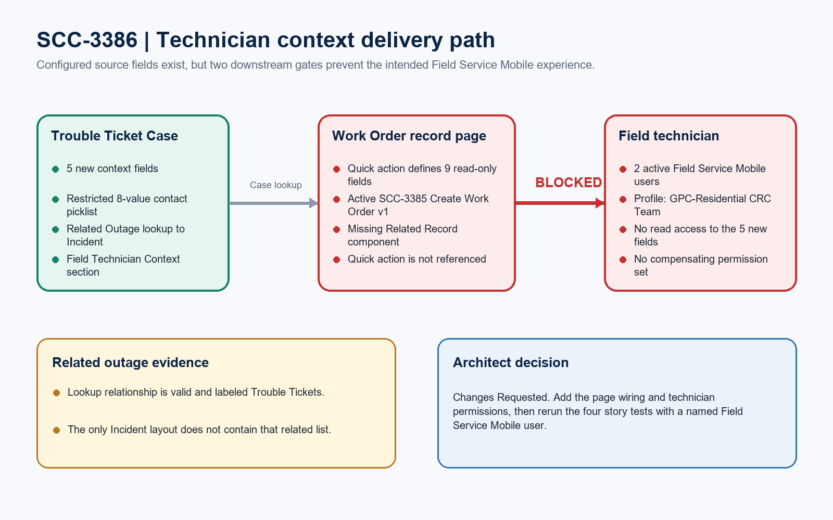
Figure 1. SCC-3386 technician context delivery path
DESIGN READING
Green is configured. Amber is incomplete. Red blocks an acceptance criterion.

Detailed configuration findings

1. Case field implementation
Field | Type | Architect evidence
Contact Preference | Restricted picklist | 8 approved values; placed first in Field Technician Context.
Special Instructions | Long Text Area (4,000) | Placed second; site-access guidance.
Tier 2 Notes | Long Text Area (32,768) | Placed third; full troubleshooting history capacity.
Equipment Information | Long Text Area (4,000) | Placed fourth; equipment identifiers and context.
Related Outage | Lookup to Incident | Placed fifth; relationship label is Trouble Tickets.

2. Field-level access
Profile | SCC-3386 field access | Interpretation
System Administrator (Admin) | Readable / editable | Configured; 16 active Field Service Mobile assignments also use this profile.
System Administrator - API Only | Readable / editable | Configured; not the business technician persona.
Standard User (Standard) | Readable / read-only | Configured, but there are zero active users on this profile.
GPC-Residential CRC Team | Not readable | Two active Field Service Mobile users; no assigned permission set grants any of the 5 new fields, Service Type, or Subscriber Report.

SECURITY BLOCKER
The only non-admin profile with active Field Service Mobile users cannot read the story fields. A read-only quick action cannot override field-level security.

UI wiring and regression evidence
Area | Result | Evidence
Quick action | Present | Case.SCC_3386_Trouble_Ticket_Details contains the 9 expected fields, all read-only; Case Status is omitted.
Work Order record page | Missing wiring | Work_Order_Record_Page contains highlights, chatter, detail, and related lists only; no force:relatedRecord component or SCC-3386 action reference.
Work Order page inventory | One page | Tooling API found exactly one WorkOrder RecordPage; last modified 10 March 2026, before SCC-3386.
Incident layout | Missing related list | Outage Incident Layout has Case Related Issues and Files, but not the Related_Outage__c Trouble Tickets relationship.
Create Work Order flow | Active/latest v1 | SCC_3385_Create_Trouble_Ticket_Work_Order is active; runtime regression remains unproven.

Read-only evidence boundary
Boundary | Evidence
Metadata retrieved | 13 named components plus the Case object container (14 source files).
Named UAT data | No Case records exist for Account 'SCC-3386 UAT Customer'.
Tests not executed | No Account, Case, Incident, Work Order, Task, or mobile-session records were created or changed.
Deployment validation | Not performed; no check-only deployment or production action was requested.

Required approval gates
Gate | Required action | Owner | Evidence needed
1 | Wire the Work Order page | Salesforce admin | Add a Related Record component using the Case lookup and SCC-3386 read-only action; verify desktop and mobile assignment.
2 | Grant technician read access | Security owner / Admin | Give the actual technician profile or permission set read access to all 9 displayed Case fields, without Case Status edit access.
3 | Add Incident related list | Salesforce admin | Place Trouble Tickets on Outage Incident Layout and confirm navigation from Case to Incident and back.
4 | Run named-persona tests | QA / Field Service | Execute all four story tests using a named Field Service Mobile user and capture record IDs/screenshots.
5 | Confirm deployment inventory | Release manager | Add Work_Order_Record_Page and Incident-Outage Incident Layout to the story component list/package.

Ready-to-paste architect response
STORY COMMENT
Architect review completed in the GreatPlainsMerge sandbox. Changes Requested: the five SCC-3386 Case fields and the nine-field read-only quick action are present, but the only Work Order record page does not reference the quick action or contain a Related Record component. The two active Field Service Mobile users on GPC-Residential CRC Team cannot read the new Case fields, and no assigned permission set compensates. The Related Outage lookup exists, but Outage Incident Layout does not include the Trouble Tickets related list. The SCC-3385 Create Work Order flow is active/latest v1, but runtime regression was not executed because this was a no-write review and the named SCC-3386 UAT data does not exist. Please complete the five gates above and rerun the story tests with a named technician before promotion. No org data, metadata, activation, or deployment changes were made.

